S3 Error Document
Trying to list the files which was uploaded to s3 bucket and not able to access and got some errors
In the below document I am redirecting to image using open option and I able to view the image
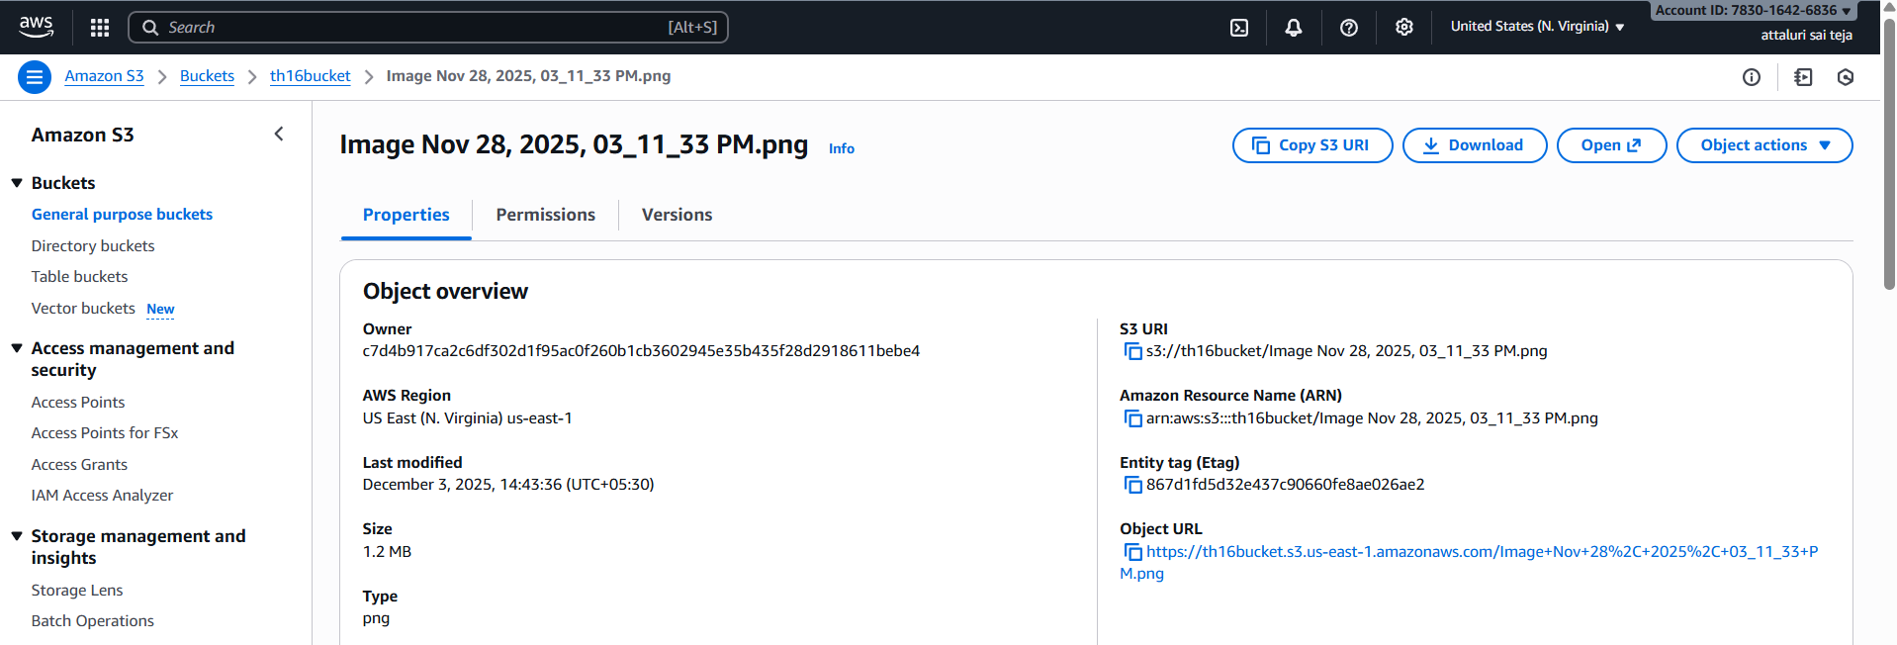
By the above step im able to witness the image.
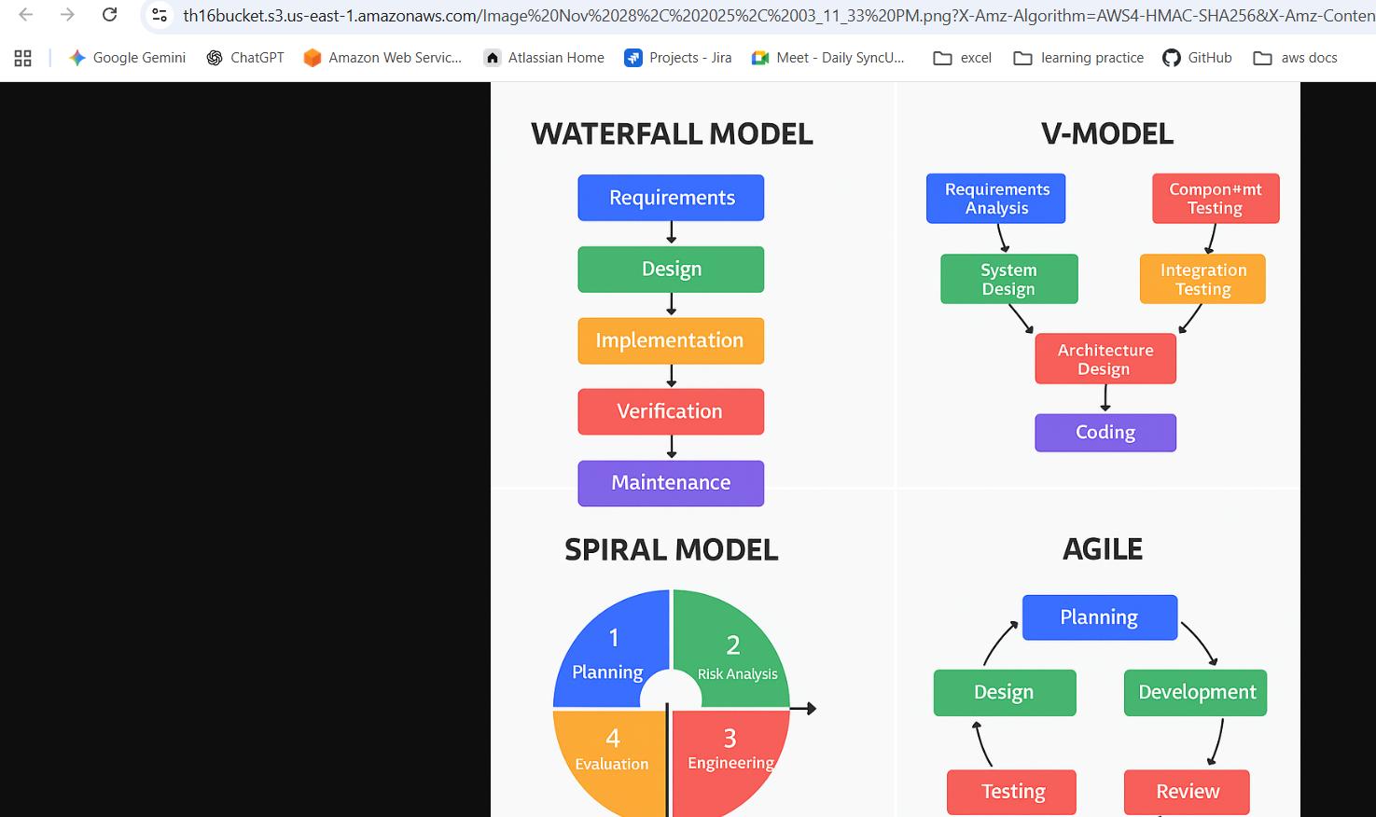

But when I am trying to access the image with link it doesn’t viewed
